МИНОБРНАУКИ РОССИИ
Санкт-Петербургский государственный
электротехнический университет
«ЛЭТИ» им. В.И. Ульянова (Ленина)
Кафедра САПР

отчет
по лабораторной работе №3
по дисциплине «Алгоритмы на графах»
Вариант 2

Студент гр. 8301 |  | Рожков В.
Преподаватель |  | Тутуева А.В.

Санкт-Петербург
2020

Постановка задачи
Реализовать алгоритм Беллмана-Форда для решения следующей задачи:
- Поиск кратчайшего пути в графе из вершины i в вершину j (bellmanFord)

Оценка временной сложности
- О(nm), где n – количество вершин, m – количество рёбер (в худшем случае O(n^3))

Описание реализованных юнит-тестов
- Нахождение позиции элемента “город”
- Попытка нахождения позиции несуществующего элемента “город”
- Установка точки отправления
- Нахождение имени элемента по позиции
- Проверка работы итератора для элемента “ребро”

Пример работы
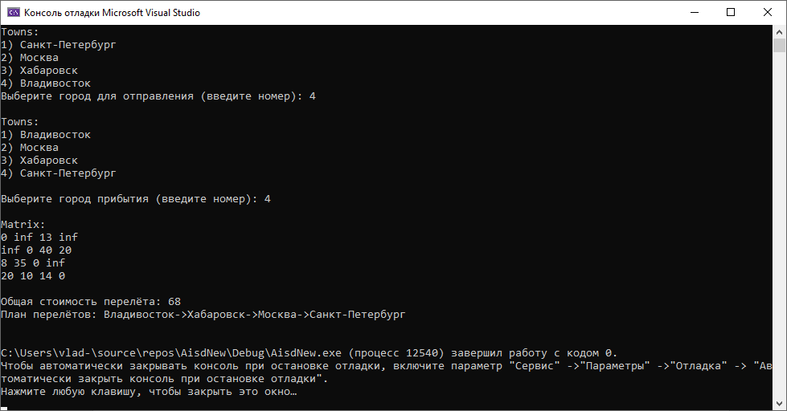
Рисунок 1
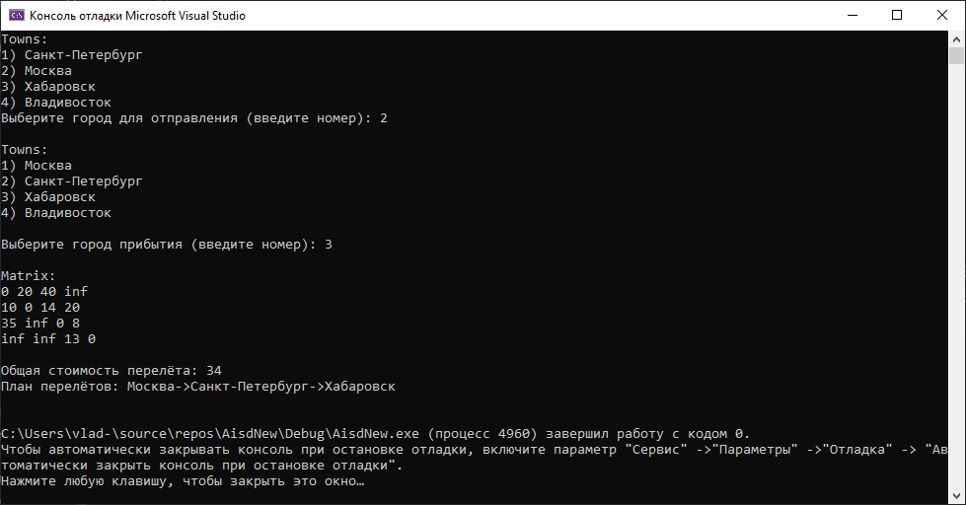
Рисунок 2

Листинг

Реализация алгоритма
#include <iostream>
#include <fstream>
#include <string>
#include <windows.h>
#include <cmath>
#include "towns.h"
#include "edges.h"
using namespace std;
int inf = 1000000; // value that bigger every weight of edges

void townsInput(towns*& townsList) // function of initializing towns
{
ifstream file; // input file
string lineInput, town; // read line and town name
int length, townRead; // length of line and amount of already read town in line
file.open("input.txt");
while (getline(file, lineInput))
{
townRead = 0; // its 0 towns read now
length = lineInput.length();
for (int i = 0; i < length; i++) // for whole line
{
if (lineInput[i] == ';')
{
if (townsList->findPosition(town)==-1) townsList->pushBack(town); // if town is not in list - add it
town = ""; // clear the town line
townRead++; // one more town read
}
else if (townRead<2) // if we need to read one or two towns more
{
town += lineInput[i]; // add symbol
}
else break; // if 2 towns read
}
}
file.close();
}

void matrixBuild(int *&matrix, towns *& townsList, int townsAmount) // building the matrix
{
ifstream file; // input file
file.open("input.txt");
string lineInput, townFrom, townTo, costForward, costBack;
int lastPosition, length, cost, from, to; // last position in line
for (int i = 0; i < townsAmount; i++)
for (int j = 0; j < townsAmount; j++)
matrix[i*townsAmount+j] = inf; // filling the matrix with infinities
for (int i = 0; i < townsAmount; i++)
matrix[i*townsAmount+i] = 0; // filling the diagonal elements
while (getline(file, lineInput))
{
townFrom = "";
townTo = "";
costForward = "";
costBack = "";
length = lineInput.length();
for (int i = 0; i < length; i++) // reading the first town
{
if (lineInput[i] == ';')
{
lastPosition = i+1; // setting the position for next town
break;
}
else townFrom += lineInput[i];
}
for (int i = lastPosition; i < length; i++) // reading the second town
{
if (lineInput[i] == ';')
{
lastPosition = i+1;
break;
}
else townTo += lineInput[i];
}
for (int i = lastPosition; i < length; i++) // reading the first cost
{
if (lineInput[i] == ';')
{
lastPosition = i+1;
break;
}
else costForward += lineInput[i];
}
for (int i = lastPosition; i < length; i++) // reading the second cost
{
if (lineInput[i] == ';') break;
else costBack += lineInput[i];
}
if (costForward != "N/A")
{
cost = 0;
length = costForward.length();
for (int i = 0; i < length; i++)
{
cost += pow(10, length - i - 1) * (costForward[i] + (0 - '0')); // counting the cost from line
}
from = townsList->findPosition(townFrom);
to = townsList->findPosition(townTo);
if (cost < matrix[from*townsAmount+to]) matrix[from*townsAmount+to] = cost;
}
if (costBack != "N/A")
{
cost = 0;
length = costBack.length();
for (int i = 0; i < length; i++)
{
cost += pow(10, length - i - 1) * (costBack[i] + (0 - '0'));
}
from = townsList->findPosition(townTo);
to = townsList->findPosition(townFrom);
if (cost < matrix[from*townsAmount+to]) matrix[from*townsAmount+to] = cost;
}
}
file.close();
}

void edgesBuild(int* matrix, int townsAmount, edges* edgesList) // building the edges
{
for (int i=0;i<townsAmount;i++)
for (int j = 0; j < townsAmount; j++)
{
if ((matrix[i * townsAmount + j] < inf) && (matrix[i * townsAmount + j] > 0)) // if weigth is bigger 0 and smaller inf - here is the edge
{
edgesList->pushBack(i, j, matrix[i * townsAmount + j]);
}
}
}

void bellmanFord(edges* edgesList, towns* townsList, int townsAmount, int lastPoint) // Bellman-Ford algorithm
{
int* distance = new int[townsAmount]; // shortest distance to each peak
int* parent = new int[townsAmount]; // previous peak with shortest way
for (int i = 1; i < townsAmount; i++) distance[i] = inf;
for (int i = 0; i < townsAmount; i++) parent[i] = inf;
distance[0] = 0;
int edgesAmount = edgesList->edgesAmountGet();
int from, to, cost;
for (int i = 0; i < townsAmount - 1; i++)
{
edgesList->refreshIterator(); // setting iterator on first town
edgesList->getIterator(from, to, cost); // getting the parameters of town
if ((distance[from] < inf) && (distance[from] + cost < distance[to])) // if there is path to this peak and this edge is better way - we choose it
{
distance[to] = distance[from] + cost;
parent[to] = from;
}
for (int j = 1; j < edgesAmount; j++)
{
edgesList->iteration();
edgesList->getIterator(from, to, cost);
if ((distance[from] < inf) && (distance[from] + cost < distance[to]))
{
distance[to] = distance[from] + cost;
parent[to] = from;
}
}
}
if (distance[lastPoint] < inf) // if there is path to this peak
{
string path = townsList->getName(lastPoint); // last point is arrival town
cout << "Общая стоимость перелёта: " << distance[lastPoint] << endl;
cout << "План перелётов: ";
while (lastPoint != 0) // while we dont get to start
{
path = townsList->getName(parent[lastPoint]) + "->" + path; // add previous peak
lastPoint = parent[lastPoint]; // set lastPoint to previous peak
}
cout << path << endl;
}

cout << endl;
delete[] distance;
delete[] parent;
}

int main()
{
SetConsoleCP(1251);
SetConsoleOutputCP(1251);
towns* townsList = new towns;
edges* edgesList = new edges;
int townsAmount, choose;
int* matrix;

townsInput(townsList);
townsAmount = townsList->townsAmountget();
townsList->outList();
cout << "Выберите город для отправления (введите номер): ";
cin >> choose;
while ((choose < 1) || (choose > townsAmount))
{
cout << "Ошибка ввода, повторите попытку" << endl;
cin >> choose;
}
townsList->setStartTown(choose-1); // set departure town
cout << endl;
townsList->outList();
cout << endl;
cout << "Выберите город прибытия (введите номер): ";
cin >> choose;
while ((choose < 1) || (choose > townsAmount))
{
cout << "Ошибка ввода, повторите попытку" << endl;
cin >> choose;
}
cout << endl;

matrix = new int[townsAmount * townsAmount];
matrixBuild(matrix, townsList, townsAmount);
cout << "Matrix:" << endl;
for (int i = 0; i < townsAmount; i++)
{
for (int j = 0; j < townsAmount; j++)
{
if (matrix[i * townsAmount + j] == inf) cout << "inf ";
else cout << matrix[i * townsAmount + j] << " ";
}
cout << endl;
}
cout << endl;

edgesBuild(matrix, townsAmount, edgesList);
bellmanFord(edgesList, townsList, townsAmount, choose-1); // last parameter is number of arrival town

delete townsList;
delete edgesList;
return 0;
}

Класс “города”
#pragma once
#include <iostream>
using namespace std;

struct town
{
string name;
town* next;
};

class towns
{
private:
town* head, * tail;
int townsAmount;

public:
towns()
{
head = nullptr;
tail = nullptr;
townsAmount = 0;
}

~towns()
{
head = nullptr;
tail = nullptr;
}

void pushBack(string townName)
{
if (!head)
{
head = new town;
tail = head;
head->next = nullptr;
head->name = townName;
townsAmount++;
}
else
{
town *newTown = new town;
tail->next = newTown;
newTown->next = nullptr;
newTown->name = townName;
tail = newTown;
townsAmount++;
}
}

int findPosition(string townName) // if town is not in list - returning -1, else returning its position
{
if (head)
{
town* current;
int position = 0;
current = head;
if (current->name == townName) return position;
while (current != tail)
{
current = current->next;
position++;
if (current->name == townName) return position;
}
return -1;
}
else return -1;
}

int townsAmountget()
{
return townsAmount;
}

void setStartTown(int number) // setting the departure town
{
town* buf, *current;
town* previous = head;
if (number != 0)
{
for (int i = 0; i < number - 1; i++)
{
previous = previous->next;
}
if (previous->next != tail) // if departure town is not in the end of list
{
current = previous->next;
previous->next = head;
buf = head->next;
head->next = current->next;
current->next = buf;
head = current;
}
else
{
current = previous->next;
previous->next = head;
current->next = head->next;
head->next = nullptr;
tail = head;
head = current;
}
}
}

string getName(int number)
{
if (head)
{
town* current = head;
for (int i = 0; i < number; i++)
current = current->next;
return current->name;
}
}

void outList()
{
if (head)
{
cout << "Towns:" << endl;
town* current = head;
cout << "1) " << current->name << endl;
for (int i = 1; i < townsAmount; i++)
{
current = current->next;
cout << i + 1 << ") " << current->name << endl;
}
}
}
};

Класс “рёбра”
#pragma once

struct edge
{
int from, to, cost;
edge* next;
};

class edges
{
private:
edge* head, * tail, * iterator;
int edgesAmount;

public:
edges()
{
head = nullptr;
tail = nullptr;
iterator = head;
edgesAmount = 0;
}

~edges()
{
head = nullptr;
tail = nullptr;
iterator = nullptr;
}

void pushBack(int fromInput, int toInput, int costInput)
{
if (head)
{
edge* newEdge = new edge;
newEdge->from = fromInput;
newEdge->to = toInput;
newEdge->cost = costInput;
newEdge->next = nullptr;
tail->next = newEdge;
tail = newEdge;
edgesAmount++;
}
else
{
head = new edge;
head->next = nullptr;
tail = head;
head->from = fromInput;
head->to = toInput;
head->cost = costInput;
edgesAmount++;
}
}

int edgesAmountGet()
{
return edgesAmount;
}

void refreshIterator()
{
iterator = head;
}

void iteration()
{
if (iterator->next) iterator = iterator->next;
}

void getIterator(int& fromOutput, int& toOutput, int& costOutput)
{
fromOutput = iterator->from;
toOutput = iterator->to;
costOutput = iterator->cost;
}
};

Юнит-тесты
#include "pch.h"
#include "CppUnitTest.h"
#include "C:\Users\vlad-\source\repos\AisdNew\AisdNew\towns.h"
#include "C:\Users\vlad-\source\repos\AisdNew\AisdNew\edges.h"

using namespace Microsoft::VisualStudio::CppUnitTestFramework;
Assert assert;

namespace UnitTest1
{
TEST_CLASS(UnitTest1)
{
public:

TEST_METHOD(townsFindPositionWithElement)
{
towns* townList = new towns;
townList->pushBack("Moscow");
assert.AreEqual(townList->findPosition("Moscow"), 0);
delete townList;
}

TEST_METHOD(townsFindPositionWithNoElement)
{
towns* townList = new towns;
townList->pushBack("Moscow");
assert.AreEqual(townList->findPosition("Saint Petersburg"), -1);
}

TEST_METHOD(townsSetStartTown)
{
towns* townList = new towns;
townList->pushBack("Moscow");
townList->pushBack("Saint Petersburg");
townList->setStartTown(1);
assert.AreEqual(townList->findPosition("Saint Petersburg"), 0);
}

TEST_METHOD(townsGetName)
{
towns* townList = new towns;
string name = "Moscow";
townList->pushBack(name);
assert.AreEqual(townList->getName(0), name);
}

TEST_METHOD(edgesGetIterator)
{
edges* edgesList = new edges;
int from, to, cost;
edgesList->pushBack(0, 1, 10);
edgesList->pushBack(1, 2, 20);
edgesList->refreshIterator();
edgesList->iteration();
edgesList->getIterator(from, to, cost);
assert.AreEqual(cost, 20);
}
};
}

Вывод:
Приобретены навыки работы с графами, а также поиска кратчайших путей в графе с помощью алгоритма Беллмана-Форда

